UNITED STATES
SECURITIES AND EXCHANGE COMMISSION
Washington, D.C. 20549
SCHEDULE 14A
Proxy Statement Pursuant to Section 14(a) of the Securities
Exchange Act of 1934 (Amendment No. )
Filed by the Registrant ☒
Filed by a Party other than the Registrant ☐
Check the appropriate box:

☐ | Preliminary Proxy Statement
☐ | Confidential, for Use of the Commission Only (as permitted by Rule 14a-6(e)(2))
☐ | Definitive Proxy Statement
☒ | Definitive Additional Materials
☐ | Soliciting Material Pursuant to § 240.14a-12

Smith & Wesson Brands, Inc.
(Name of Registrant as Specified in its Charter)

(Name of Person(s) Filing Proxy Statement, if Other Than the Registrant)

Payment of Filing Fee (Check the appropriate box):

☒ | No fee required.
☐ | Fee paid previously with preliminary materials.
☐ | Fee computed on table in exhibit required by Item 25(b) per Exchange Act Rules 14a-6(i)(1) and 0-11.

mith & Wesson® 2021 NOTICE OF ANNUAL SHAREHOLDER MEETING AND PROXY STATEMENT

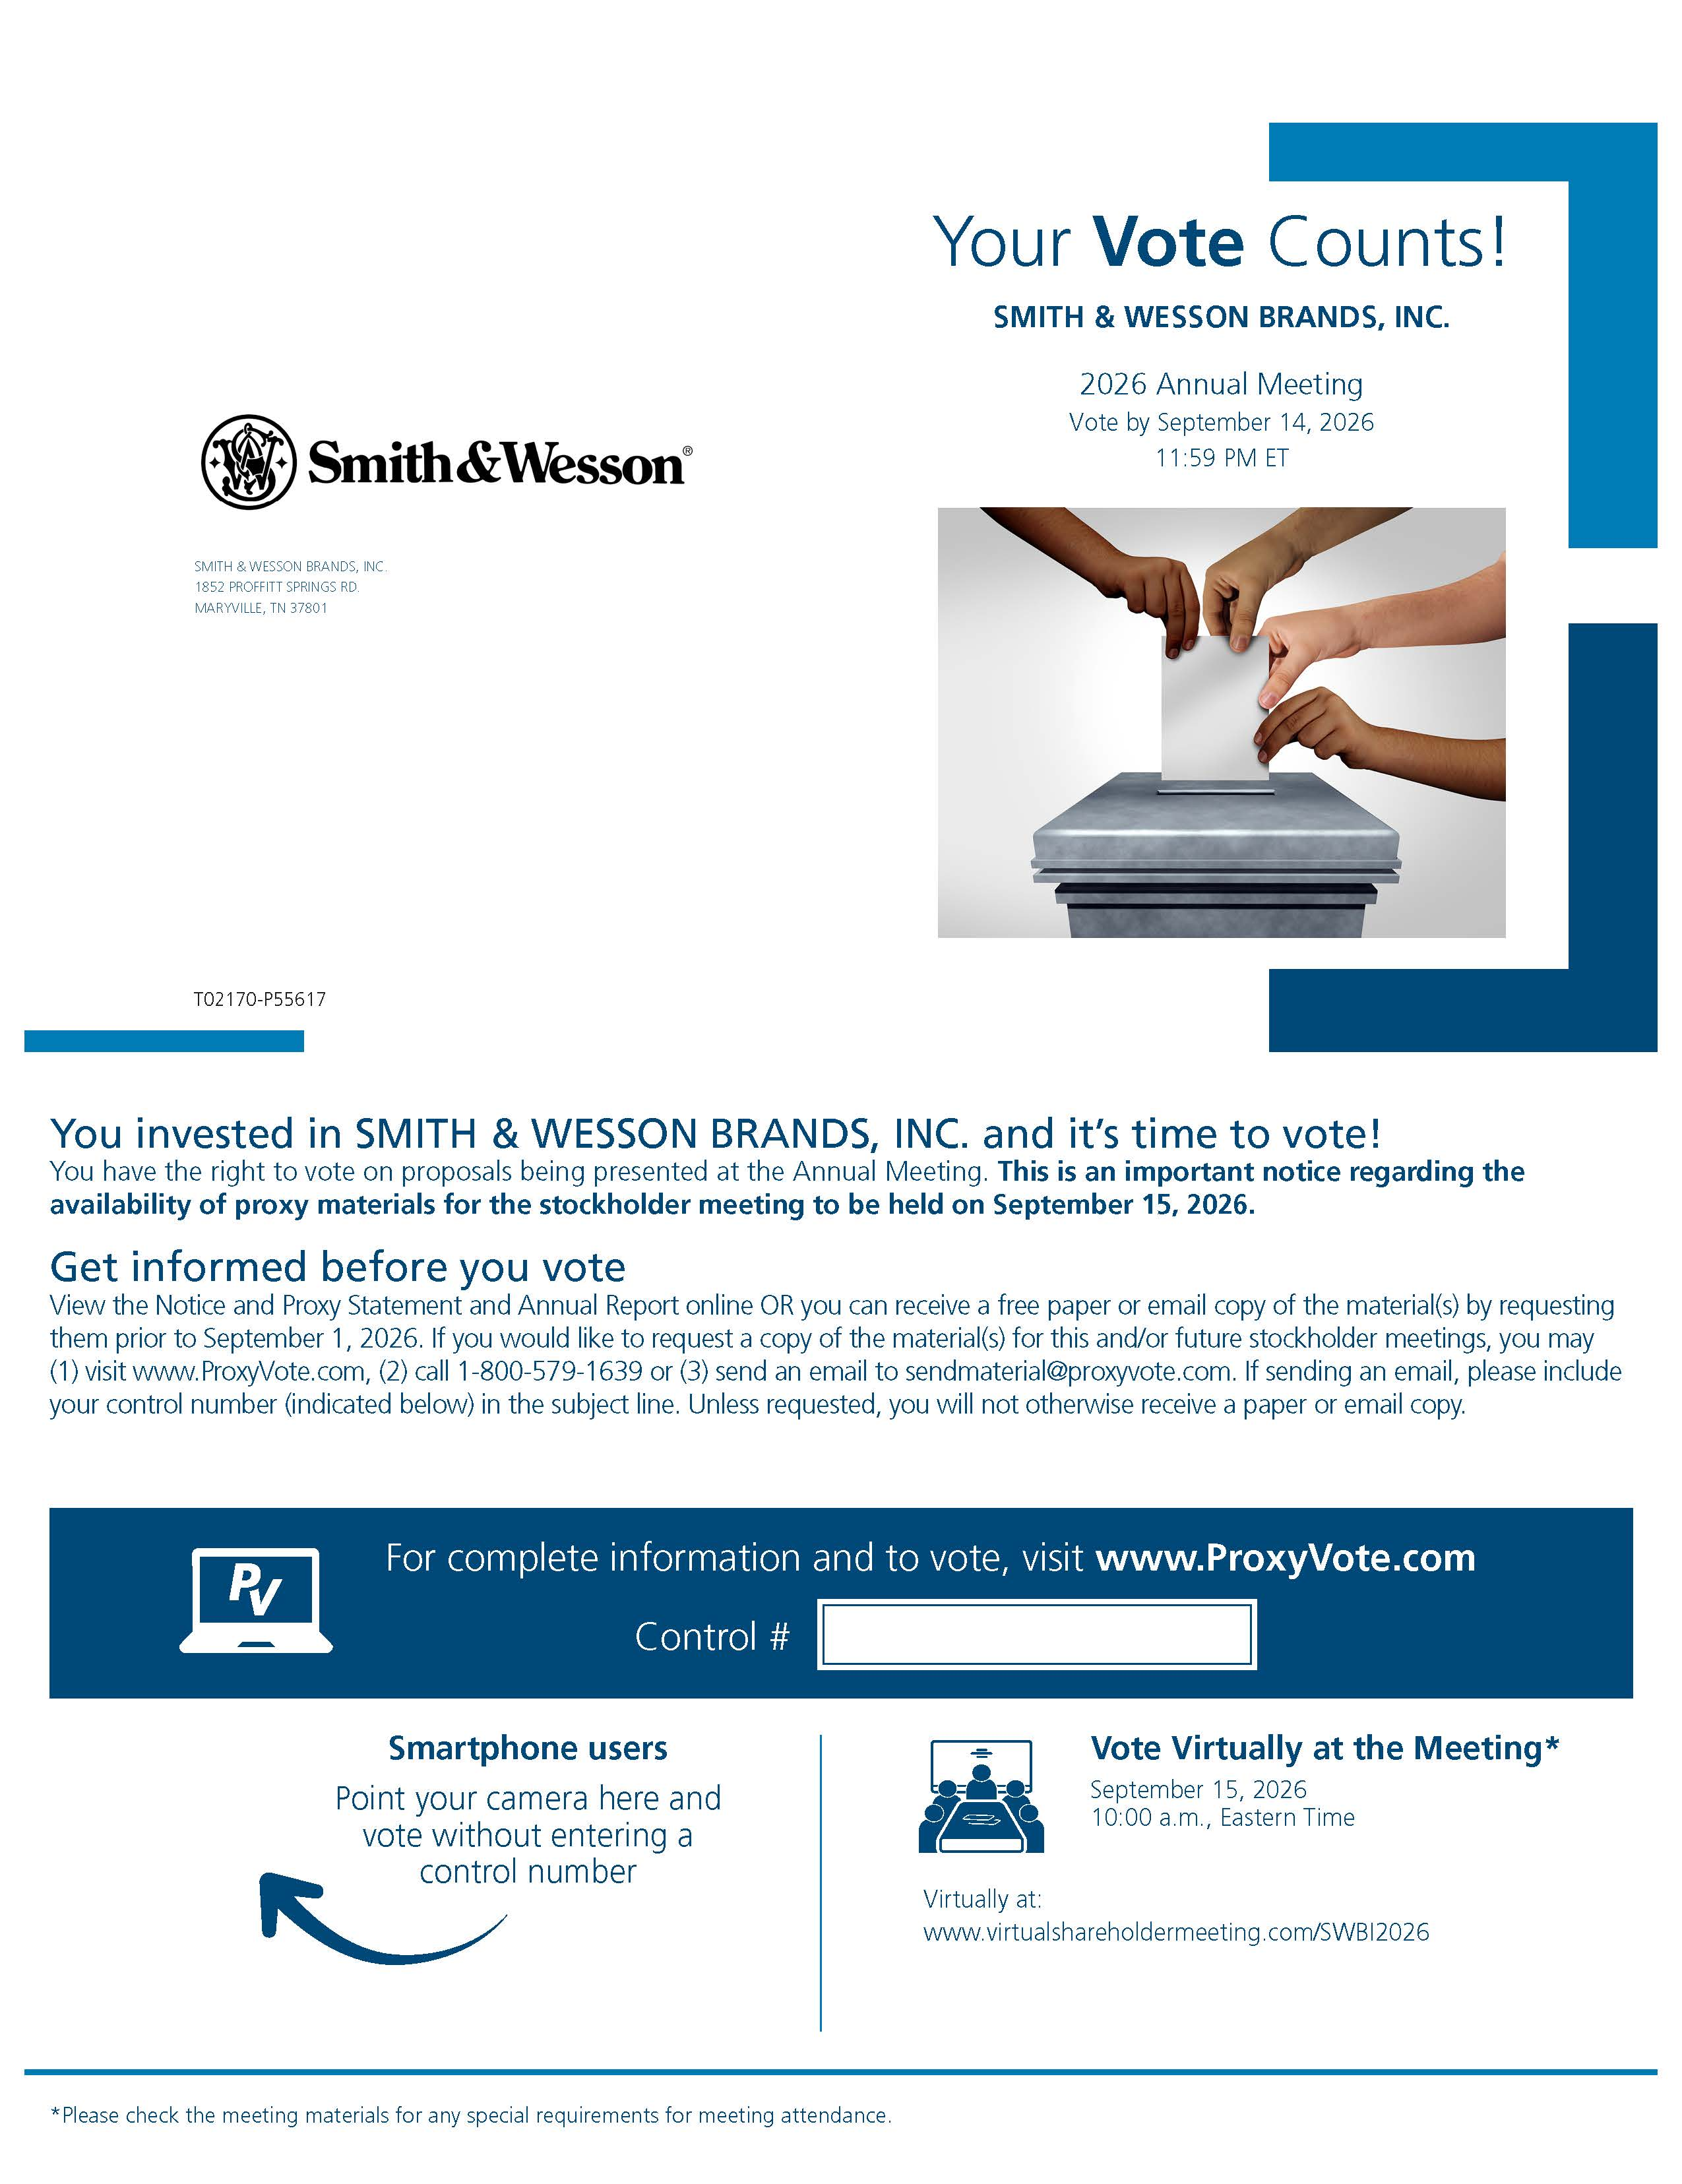

Your Vote Counts! SMITH & WESSON BRANDS, INC. 2022 Annual Meeting Vote by September 11, 2022 11:59 PM ET SMITH & WESSON SMITH & WESSON BRANDS, INC. 2100 ROOSEVELT AVENUE SPRINGFIELD, MA 01104 D88651-P78625 You invested in SMITH & WESSON BRANDS, INC. and it’s time to vote! You have the right to vote on proposals being presented at the Annual Meeting. This is an important notice regarding the availability of proxy materials for the stockholder meeting to be held on September 12, 2022. Get informed before you vote View the Notice and Proxy Statement and Annual Report online OR you can receive a free paper or email copy of the material(s) by requesting them prior to August 29, 2022. If you would like to request a copy of the material(s) for this and/or future stockholder meetings, you may (1) visit www.ProxyVote.com, (2) call 1-800-579-1639, or (3) send an email to sendmaterial@proxyvote.com. If sending an email, please include your control number (indicated below) in the subject line. Unless requested, you will not otherwise receive a paper or email copy. For complete information and to vote, visit www.ProxyVote.com Control # Smartphone users Point your camera here and vote without entering a control number Vote Virtually at the Meeting* September 12, 2022 10:00 a.m., Eastern Time Virtually at: www.virtualshareholdermeeting.com/SWBI2022 *Please check the meeting materials for any special requirements for meeting attendance. V1.1

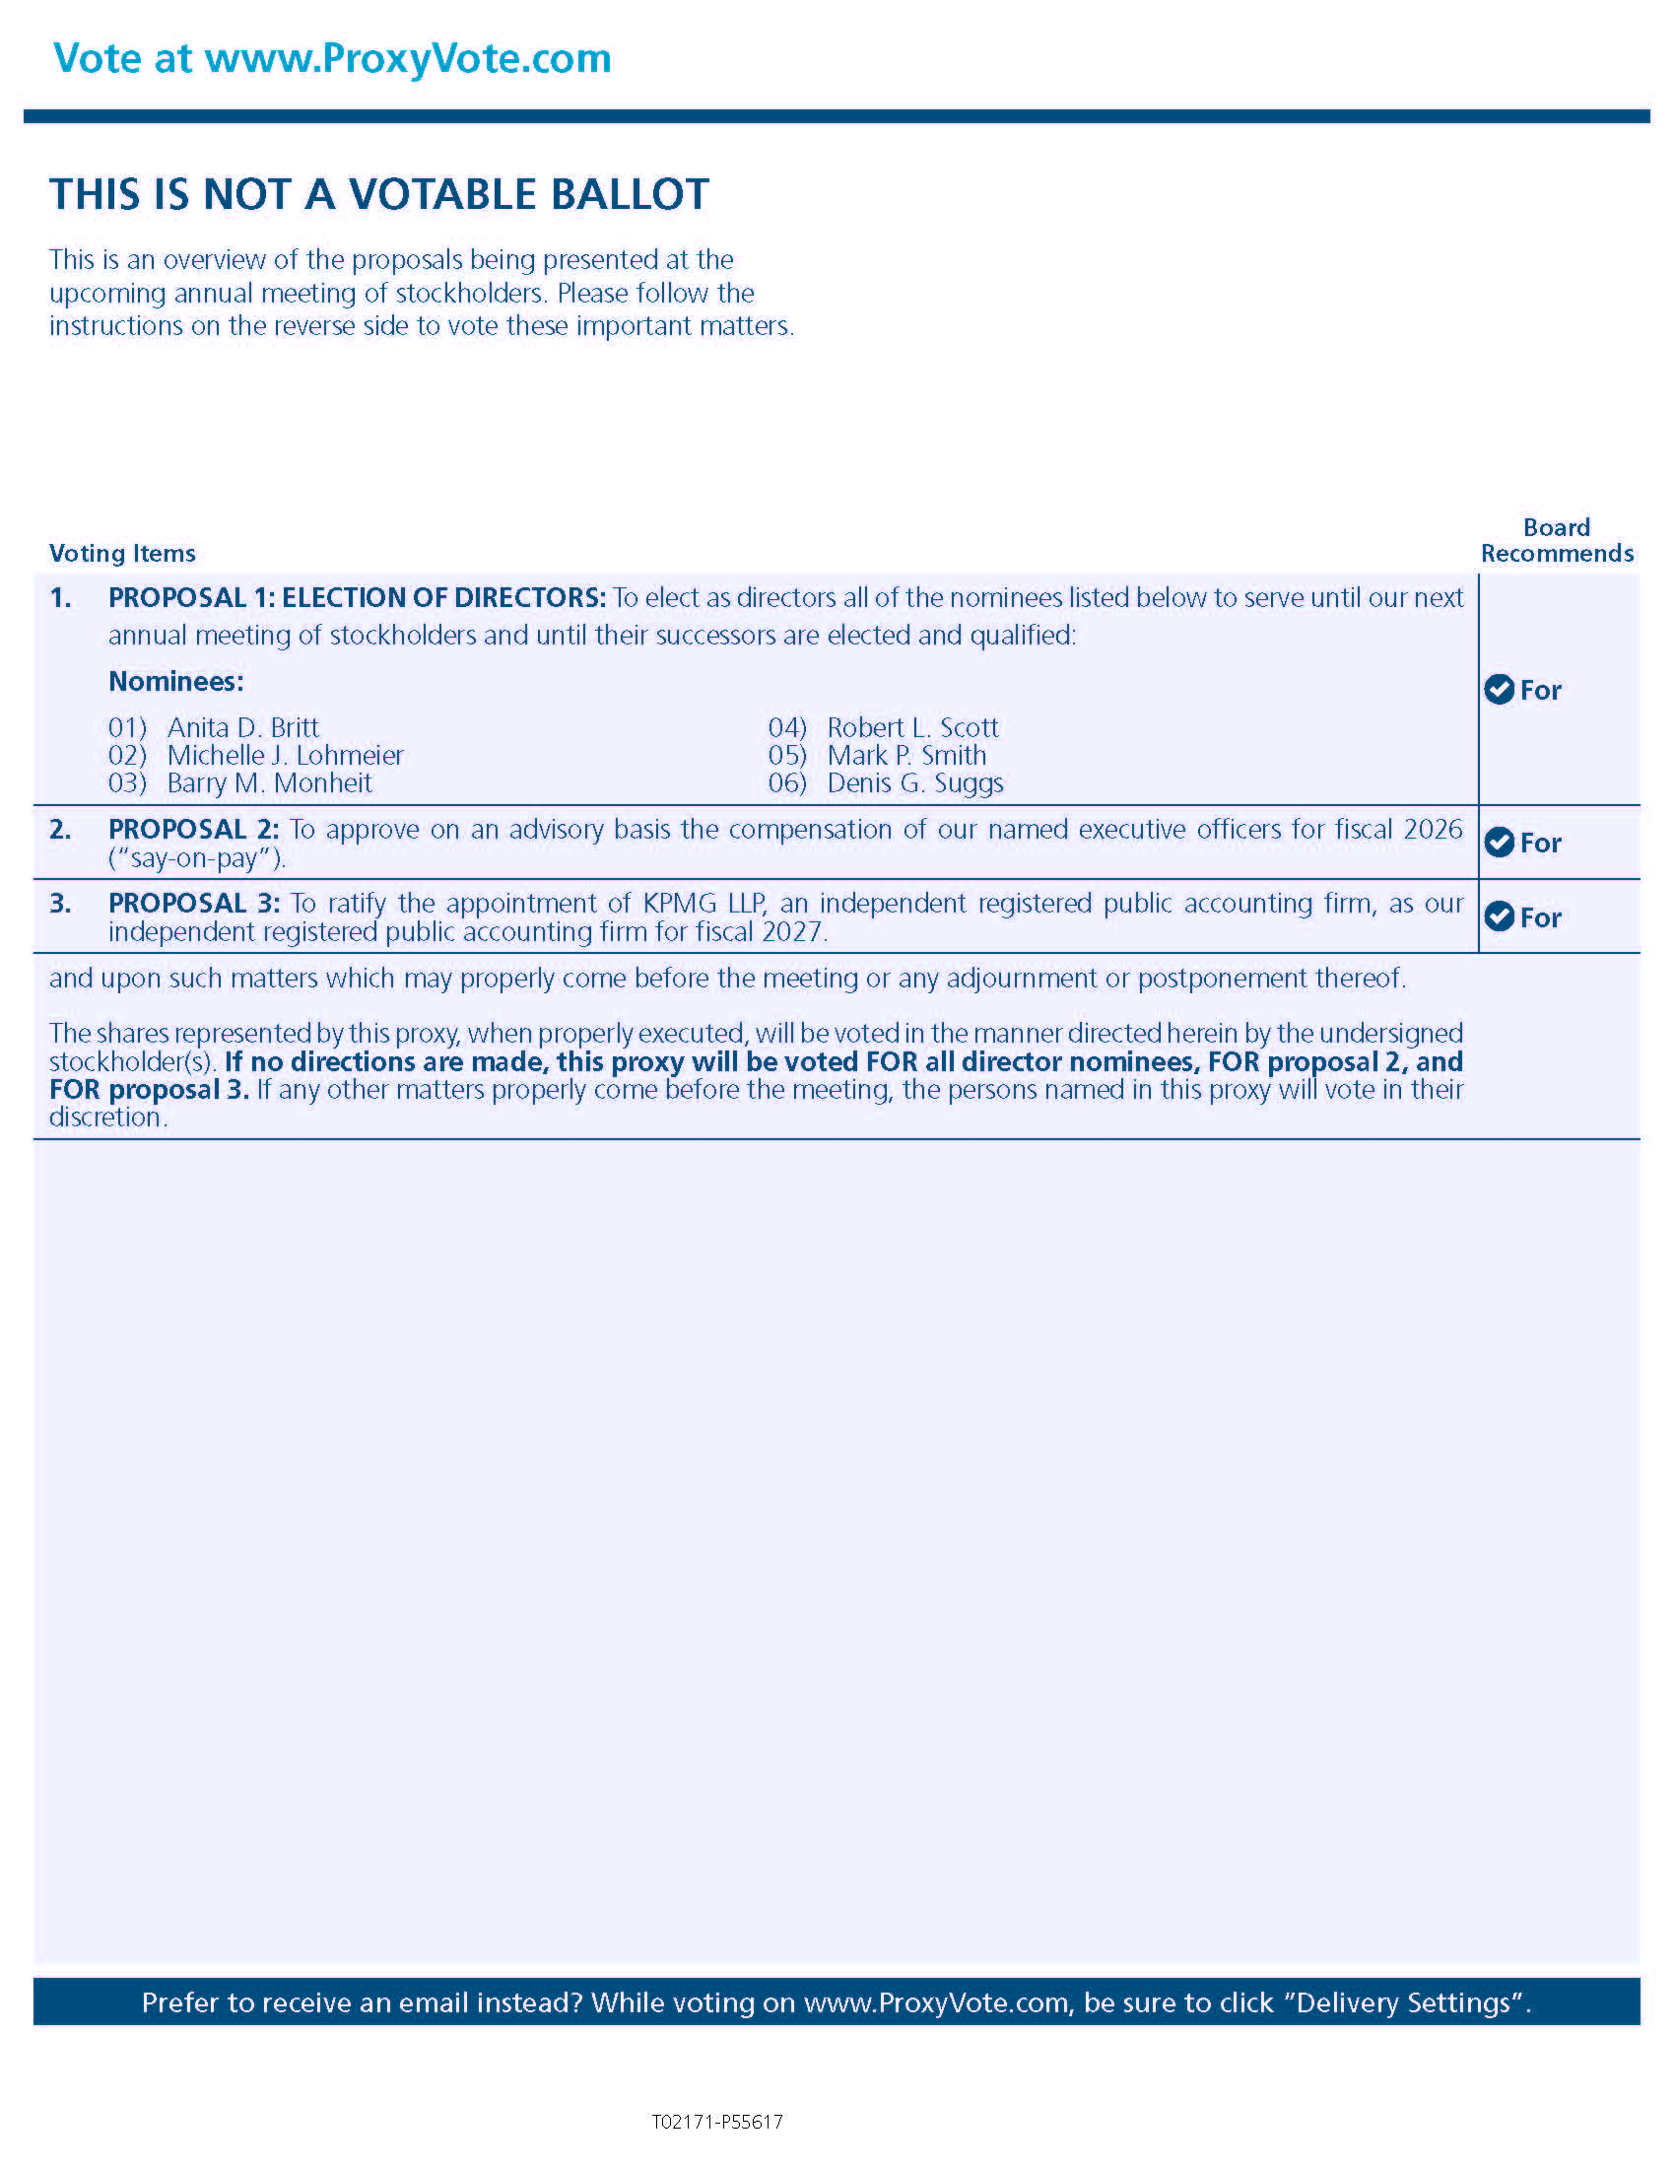

Vote at www.ProxyVote.com THIS IS NOT A VOTABLE BALLOT This is an overview of the proposals being presented at the upcoming stockholder meeting. Please follow the instructions on the reverse side to vote these important matters. Voting Items Board Recommends 1. PROPOSAL 1: ELECTION OF DIRECTORS: To elect as directors all of the nominees listed below to serve until our next annual meeting of stockholders and until their successors are elected and qualified: Nominees: 01) Anita D. Britt 02) Fred M. Diaz 03) John B. Furman04) Michael F. Golden 05) Barry M. Monheit 06) Robert L. Scott 07) Mark P. Smith 08) Denis G. Suggs For 2. PROPOSAL 2: To approve on an advisory basis the compensation of our named executive officers for fiscal 2022 (“say-on-pay”). For 3. PROPOSAL 3: To approve the Smith & Wesson Brands, Inc. 2022 Incentive Stock Plan. For 4. PROPOSAL 4: To ratify the appointment of Deloitte & Touche LLP, an independent registered public accounting firm, as our independent registered public accountant for fiscal 2023. For5. PROPOSAL 5: A stockholder proposal (develop a human rights policy). Against6. PROPOSAL 6: A stockholder proposal (simple majority voting). Against and upon such matters which may properly come before the meeting or any adjournment or postponement thereof. The shares represented by the proxy, when properly executed, will be voted in the manner directed herein by the undersigned stockholder(s). If no directions are made, the proxy will be voted FOR all directors, FOR proposals 2, 3, and 4, and AGAINST proposals 5 and 6. If any other matters properly come before the meeting, the persons named in the proxy will vote in their discretion. Prefer to receive an email instead? While voting on www.ProxyVote.com, be sure to click “Sign up for E-delivery”. D88652-P78625

