UNITED STATES
SECURITIES AND EXCHANGE COMMISSION
Washington, D.C. 20549

FORM 8-K

CURRENT REPORT
Pursuant to Section 13 or 15(d)
of the Securities Exchange Act of 1934
Date of Report (Date of earliest event reported): July 15, 2026

Smith & Wesson Brands, Inc.
(Exact Name of Registrant as Specified in Charter)

Nevada |  | 001-31552 |  | 87-0543688
(State or other jurisdiction  of incorporation) |  | (Commission  File Number) |  | (IRS Employer  Identification No.)
1852 Proffitt Springs Road
Maryville, Tennessee 37801
(Address of principal executive offices) (Zip Code)
(800) 331-0852
(Registrant’s telephone number, including area code)

Check the appropriate box below if the Form 8-K filing is intended to simultaneously satisfy the filing obligation of the registrant under any of the following provisions (see General Instruction A.2. below):

☐ | Written communications pursuant to Rule 425 under the Securities Act (17 CFR 230.425)

☐ | Soliciting material pursuant to Rule 14a-12 under the Exchange Act (17 CFR 240.14a-12)

☐ | Pre-commencement communications pursuant to Rule 14d-2(b) under the Exchange Act (17 CFR 240.14d-2(b))

☐ | Pre-commencement communications pursuant to Rule 13e-4(c) under the Exchange Act (17 CFR 240.13e-4(c))
Securities registered pursuant to Section 12(b) of the Act:

Title of each class |  | Trading  Symbol(s) |  | Name of each exchange  on which registered
Common Stock, Par Value $0.001 per Share |  | SWBI |  | Nasdaq Global Select Market
Indicate by check mark whether the registrant is an emerging growth company as defined in Rule 405 of the Securities Act of 1933 (17 §CFR 230.405) or Rule 12b-2 of the Securities Exchange Act of 1934 (17 CFR §240.12b-2).
Emerging growth company ☐
If an emerging growth company, indicate by check mark if the registrant has elected not to use the extended transition period for complying with any new or revised financial accounting standards provided pursuant to Section 13(a) of the Exchange Act. ☐

Item 7.01. | Regulation FD Disclosure.
On July 15, 2026, Smith & Wesson Brands, Inc. hosted an investor day at its corporate headquarters. Attached as Exhibit 99.1 is the related slide presentation.
The information provided pursuant to this Item 7.01, including Exhibit 99.1 in Item 9.01, is “furnished” and shall not be deemed to be “filed” with the Securities and Exchange Commission or incorporated by reference in any filing under the Securities Exchange Act of 1934, as amended, or the Securities Act of 1933, as amended, except as shall be expressly set forth by specific reference in any such filings.

Item 9.01. | Financial Statements and Exhibits.

 | (d) | Exhibits.

Exhibit No.
99.1 |  | Investor Day 2026 presentation, dated July 15, 2026
104 |  | Cover Page Interactive Data File (embedded within the Inline XBRL document)

SIGNATURES
Pursuant to the requirements of the Securities Exchange Act of 1934, the registrant has duly caused this report to be signed on its behalf by the undersigned hereunto duly authorized.

 |  | SMITH & WESSON BRANDS, INC.
Date: July 15, 2026 |  | By: |  | /s/ Deana L. McPherson
 |  |  |  | Deana L. McPherson
 |  |  |  | Executive Vice President, Chief Financial Officer, Treasurer, and Assistant Secretary
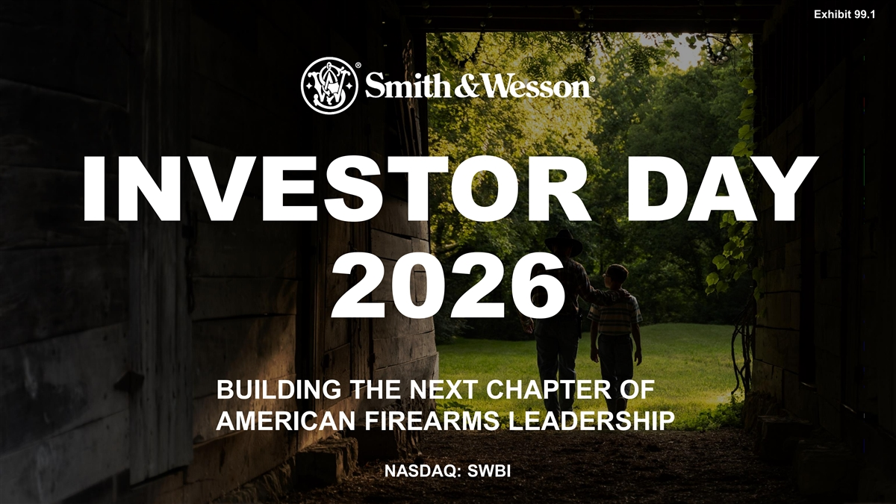
Exhibit 99.1 INVESTOR DAY 2026 BUILDING THE NEXT CHAPTER OF AMERICAN FIREARMS LEADERSHIP NASDAQ: SWBI © 2026 SMITH & WESSON BRANDS, INC. ALL RIGHTS RESERVED.

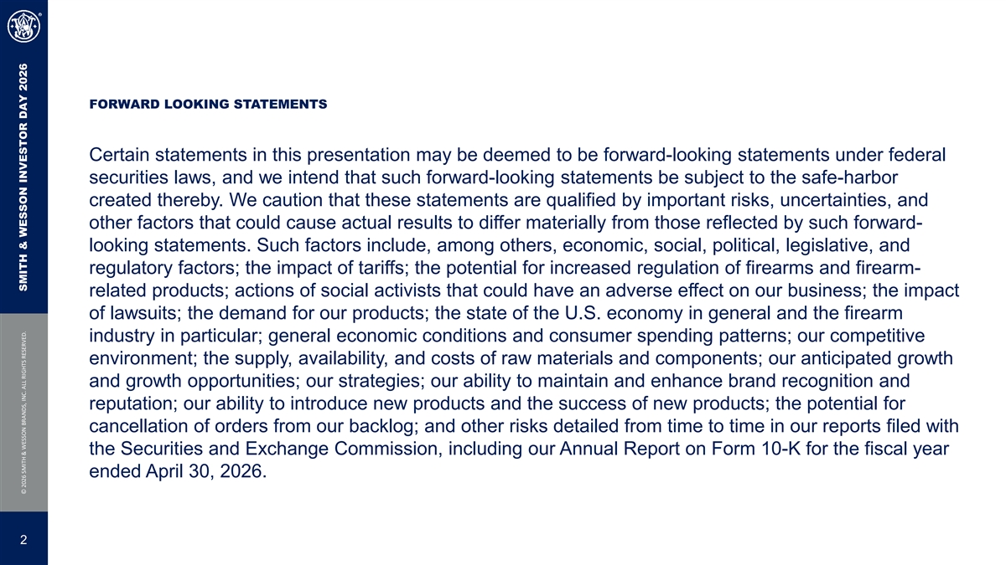
FORWARD LOOKING STATEMENTS Certain statements in this presentation may be deemed to be forward-looking statements under federal securities laws, and we intend that such forward-looking statements be subject to the safe-harbor created thereby. We caution that these statements are qualified by important risks, uncertainties, and other factors that could cause actual results to differ materially from those reflected by such forward- looking statements. Such factors include, among others, economic, social, political, legislative, and regulatory factors; the impact of tariffs; the potential for increased regulation of firearms and firearm- related products; actions of social activists that could have an adverse effect on our business; the impact of lawsuits; the demand for our products; the state of the U.S. economy in general and the firearm industry in particular; general economic conditions and consumer spending patterns; our competitive environment; the supply, availability, and costs of raw materials and components; our anticipated growth and growth opportunities; our strategies; our ability to maintain and enhance brand recognition and reputation; our ability to introduce new products and the success of new products; the potential for cancellation of orders from our backlog; and other risks detailed from time to time in our reports filed with the Securities and Exchange Commission, including our Annual Report on Form 10-K for the fiscal year ended April 30, 2026. 2 © 2026 SMITH & WESSON BRANDS, INC. ALL RIGHTS RESERVED. SMITH & WESSON INVESTOR DAY 2026

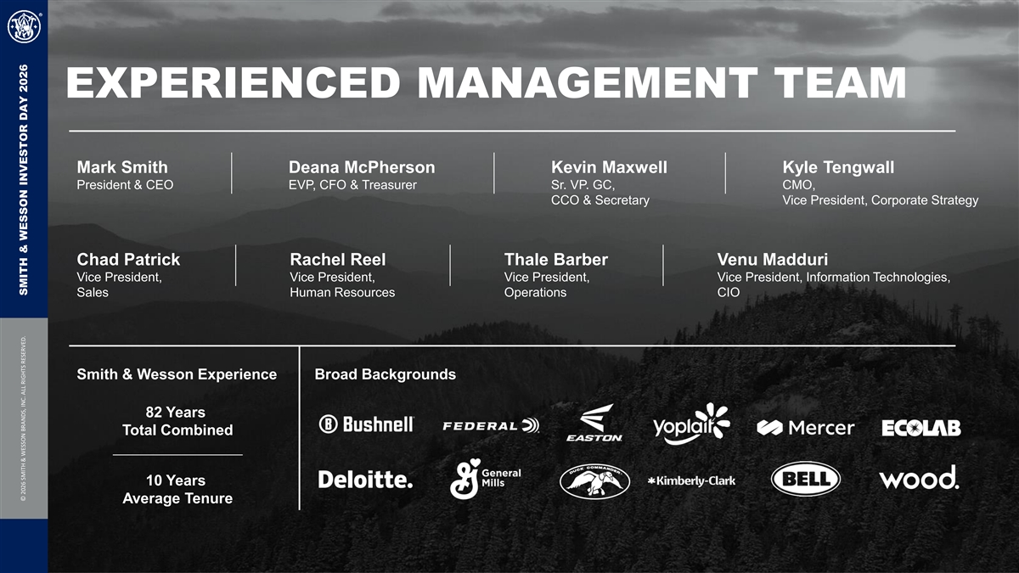
EXPERIENCED MANAGEMENT TEAM Mark Smith Deana McPherson Kevin Maxwell Kyle Tengwall President & CEO EVP, CFO & Treasurer Sr. VP. GC, CMO, CCO & Secretary Vice President, Corporate Strategy Chad Patrick Rachel Reel Thale Barber Venu Madduri Vice President, Vice President, Vice President, Vice President, Information Technologies, Sales Human Resources Operations CIO Smith & Wesson Experience Broad Backgrounds 82 Years Total Combined 10 Years Average Tenure © 2026 SMITH & WESSON BRANDS, INC. ALL RIGHTS RESERVED. SMITH & WESSON INVESTOR DAY 2026

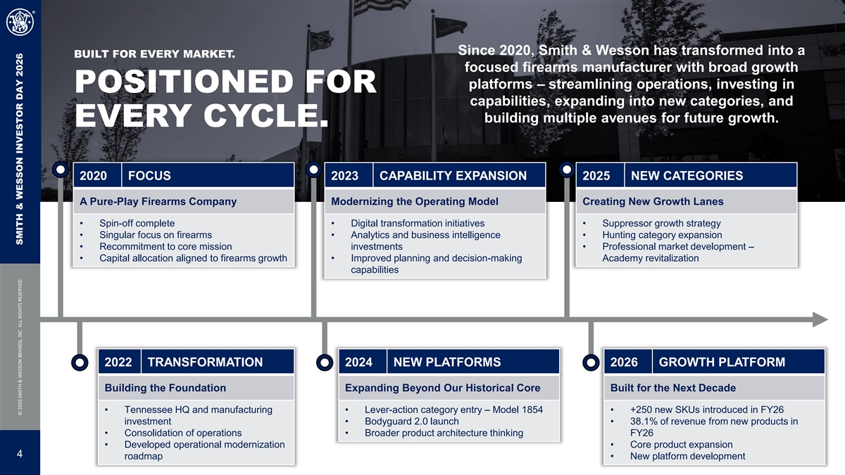
Since 2020, Smith & Wesson has transformed into a BUILT FOR EVERY MARKET. focused firearms manufacturer with broad growth platforms – streamlining operations, investing in POSITIONED FOR capabilities, expanding into new categories, and building multiple avenues for future growth. EVERY CYCLE. 2020 FOCUS 2023 CAPABILITY EXPANSION 2025 NEW CATEGORIES A Pure-Play Firearms Company Modernizing the Operating Model Creating New Growth Lanes • Spin-off complete• Digital transformation initiatives• Suppressor growth strategy • Singular focus on firearms• Analytics and business intelligence • Hunting category expansion • Recommitment to core mission investments• Professional market development – • Capital allocation aligned to firearms growth• Improved planning and decision-making Academy revitalization capabilities 2022 TRANSFORMATION 2024 NEW PLATFORMS 2026 GROWTH PLATFORM Building the Foundation Expanding Beyond Our Historical Core Built for the Next Decade • Tennessee HQ and manufacturing • Lever-action category entry – Model 1854• +250 new SKUs introduced in FY26 investment• Bodyguard 2.0 launch• 38.1% of revenue from new products in • Consolidation of operations• Broader product architecture thinking FY26 • Developed operational modernization • Core product expansion 4 roadmap• New platform development © 2026 SMITH & WESSON BRANDS, INC. ALL RIGHTS RESERVED. SMITH & WESSON INVESTOR DAY 2026

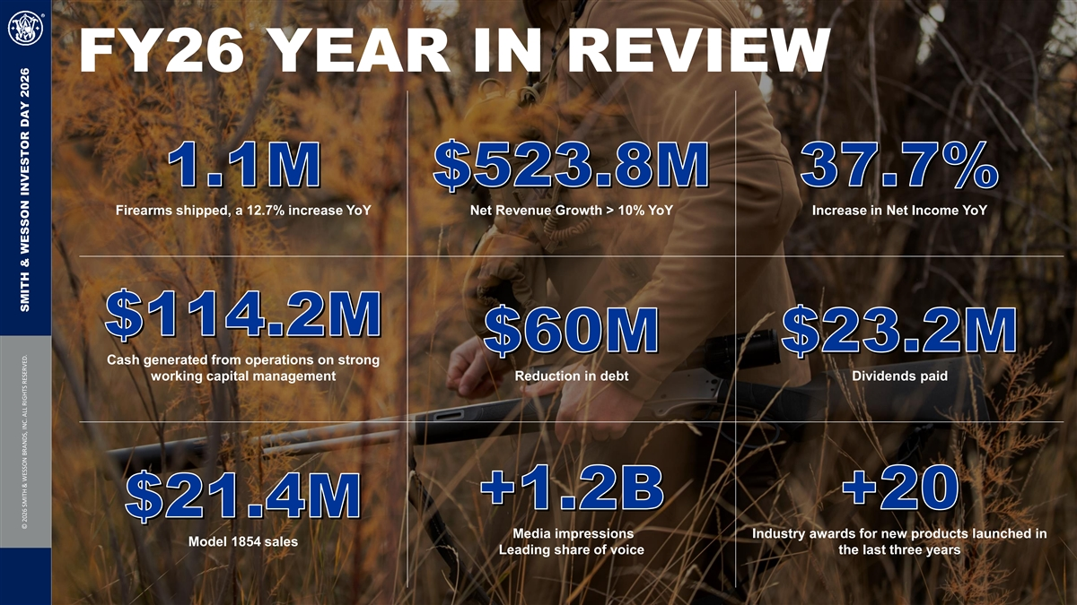
FY26 YEAR IN REVIEW 1.1M $523.8M 37.7% Firearms shipped, a 12.7% increase YoY Net Revenue Growth > 10% YoY Increase in Net Income YoY $114.2M $60M $23.2M Cash generated from operations on strong working capital management Reduction in debt Dividends paid +1.2B +20 $21.4M Media impressions Industry awards for new products launched in Model 1854 sales Leading share of voice the last three years © 2026 SMITH & WESSON BRANDS, INC. ALL RIGHTS RESERVED. SMITH & WESSON INVESTOR DAY 2026

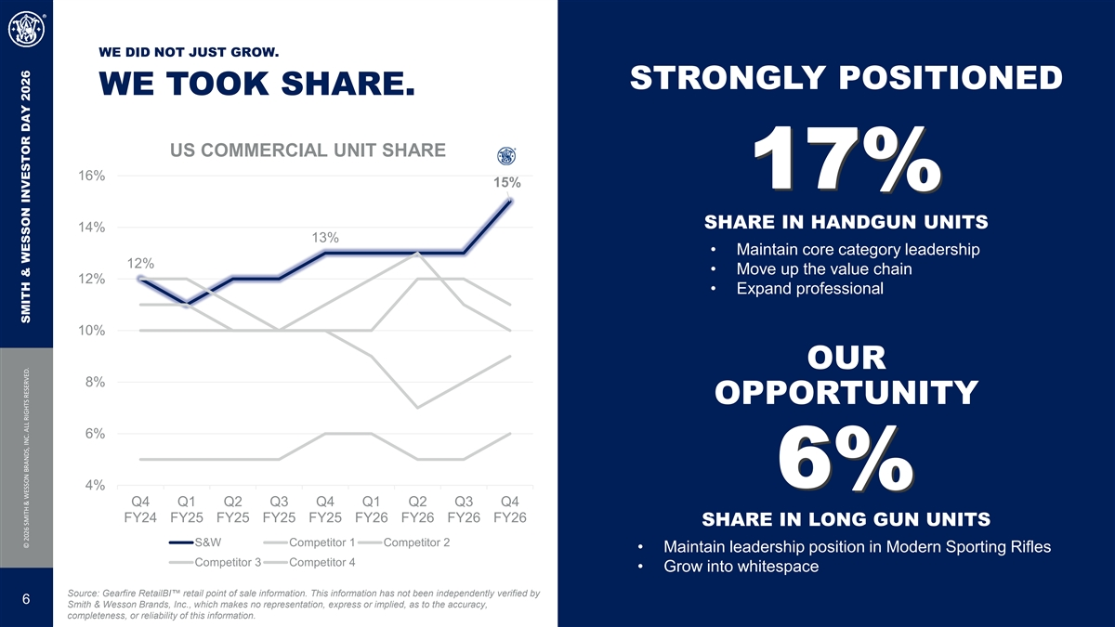
WE DID NOT JUST GROW. STRONGLY POSITIONED WE TOOK SHARE. US COMMERCIAL UNIT SHARE 16% 15% 17% SHARE IN HANDGUN UNITS 14% 13% • Maintain core category leadership 12% • Move up the value chain 12% • Expand professional 10% OUR 8% OPPORTUNITY 6% 6% 4% Q4 Q1 Q2 Q3 Q4 Q1 Q2 Q3 Q4 FY24 FY25 FY25 FY25 FY25 FY26 FY26 FY26 FY26 SHARE IN LONG GUN UNITS S&W Competitor 1 Competitor 2 • Maintain leadership position in Modern Sporting Rifles Competitor 3 Competitor 4 • Grow into whitespace Source: Gearfire RetailBI retail point of sale information. This information has not been independently verified by 6 Smith & Wesson Brands, Inc., which makes no representation, express or implied, as to the accuracy, completeness, or reliability of this information. © 2026 SMITH & WESSON BRANDS, INC. ALL RIGHTS RESERVED. SMITH & WESSON INVESTOR DAY 2026

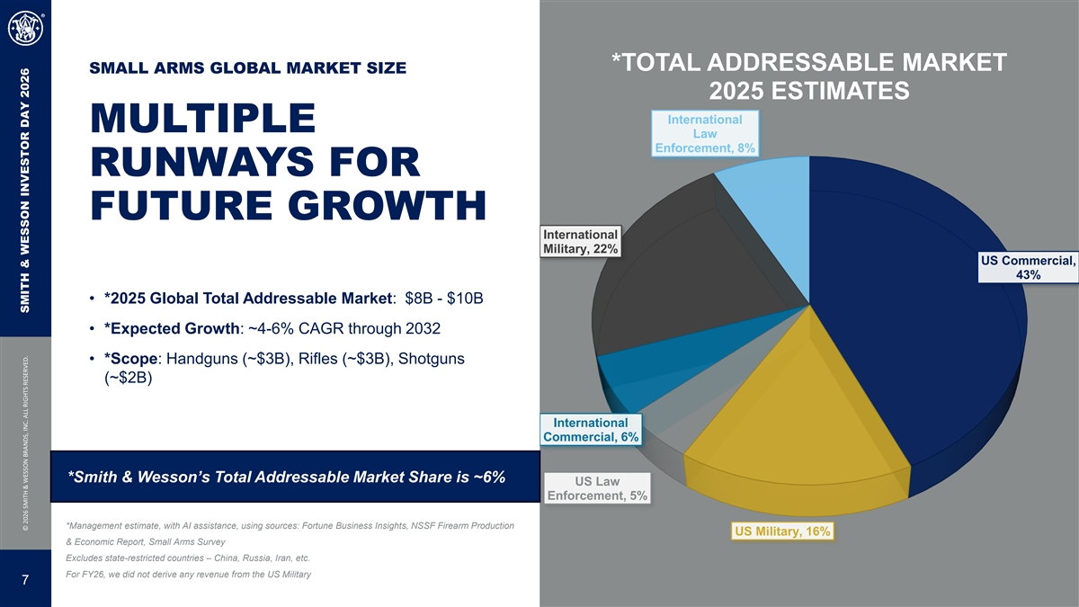
*TOTAL ADDRESSABLE MARKET SMALL ARMS GLOBAL MARKET SIZE 2025 ESTIMATES International MULTIPLE Law Enforcement, 8% RUNWAYS FOR FUTURE GROWTH International Military, 22% US Commercial, 43% • *2025 Global Total Addressable Market: $8B - $10B • *Expected Growth: ~4-6% CAGR through 2032 • *Scope: Handguns (~$3B), Rifles (~$3B), Shotguns (~$2B) International Commercial, 6% *Smith & Wesson’s Total Addressable Market Share is ~6% US Law Enforcement, 5% *Management estimate, with AI assistance, using sources: Fortune Business Insights, NSSF Firearm Production US Military, 16% & Economic Report, Small Arms Survey Excludes state-restricted countries – China, Russia, Iran, etc. For FY26, we did not derive any revenue from the US Military 7 © 2026 SMITH & WESSON BRANDS, INC. ALL RIGHTS RESERVED. SMITH & WESSON INVESTOR DAY 2026

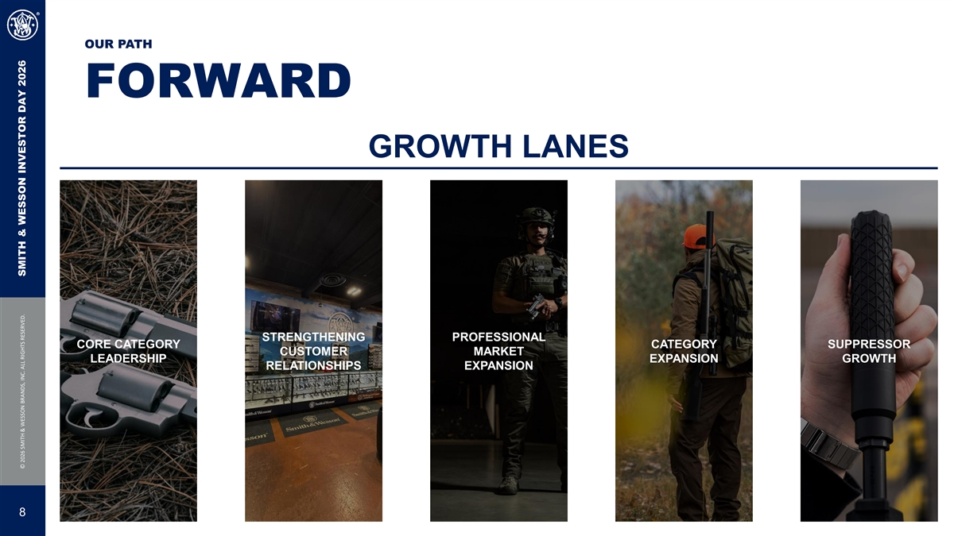
OUR PATH FORWARD GROWTH LANES STRENGTHENING PROFESSIONAL CORE CATEGORY CATEGORY SUPPRESSOR CUSTOMER MARKET LEADERSHIP EXPANSION GROWTH RELATIONSHIPS EXPANSION 8 © 2026 SMITH & WESSON BRANDS, INC. ALL RIGHTS RESERVED. SMITH & WESSON INVESTOR DAY 2026

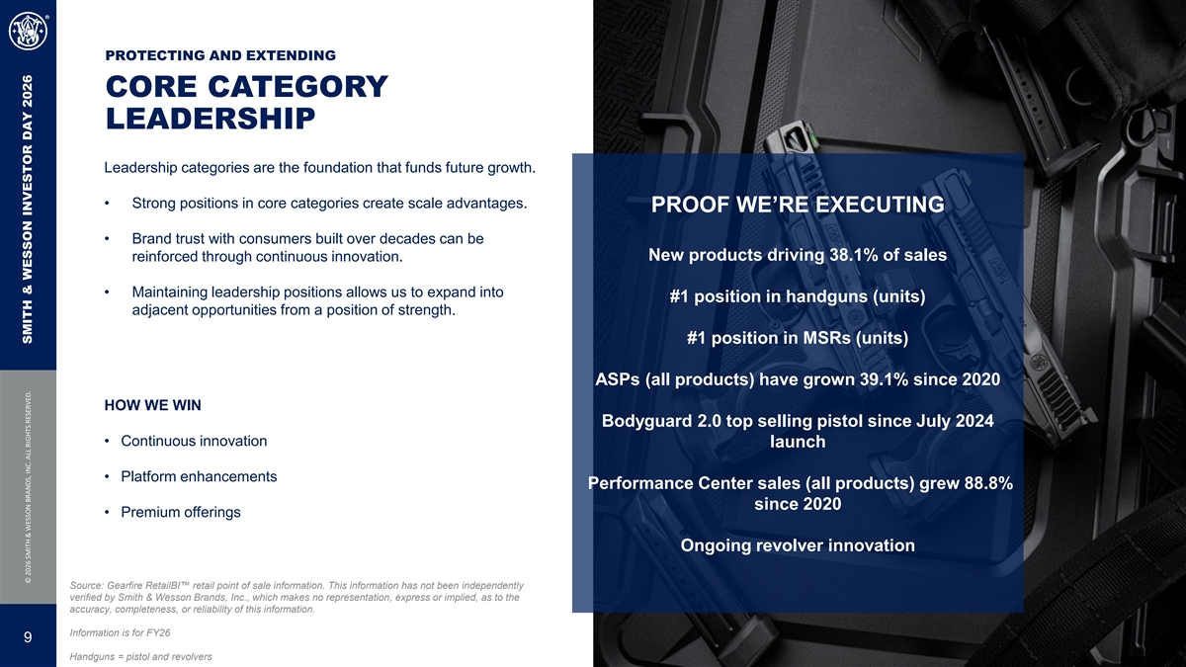
PROTECTING AND EXTENDING CORE CATEGORY LEADERSHIP Leadership categories are the foundation that funds future growth. • Strong positions in core categories create scale advantages. PROOF WE’RE EXECUTING • Brand trust with consumers built over decades can be New products driving 38.1% of sales reinforced through continuous innovation. • Maintaining leadership positions allows us to expand into #1 position in handguns (units) adjacent opportunities from a position of strength. #1 position in MSRs (units) ASPs (all products) have grown 39.1% since 2020 HOW WE WIN Bodyguard 2.0 top selling pistol since July 2024 • Continuous innovation launch • Platform enhancements Performance Center sales (all products) grew 88.8% since 2020 • Premium offerings Ongoing revolver innovation Source: Gearfire RetailBI retail point of sale information. This information has not been independently verified by Smith & Wesson Brands, Inc., which makes no representation, express or implied, as to the accuracy, completeness, or reliability of this information. Information is for FY26 9 Handguns = pistol and revolvers © 2026 SMITH & WESSON BRANDS, INC. ALL RIGHTS RESERVED. SMITH & WESSON INVESTOR DAY 2026

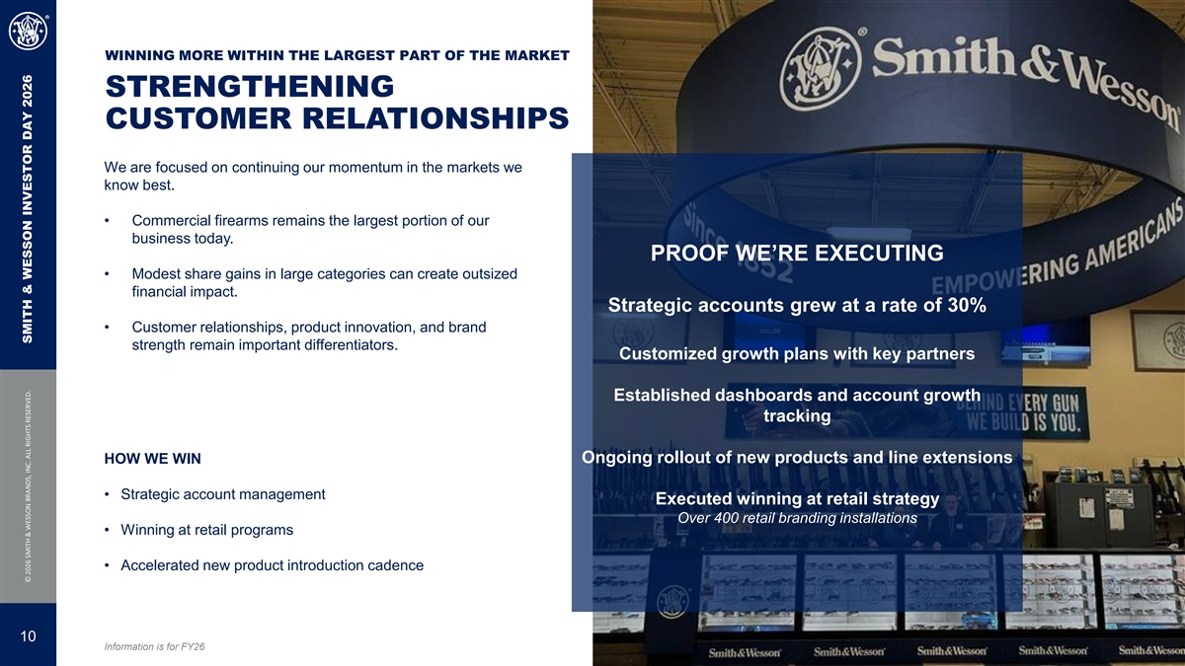
WINNING MORE WITHIN THE LARGEST PART OF THE MARKET STRENGTHENING CUSTOMER RELATIONSHIPS We are focused on continuing our momentum in the markets we know best. • Commercial firearms remains the largest portion of our business today. PROOF WE’RE EXECUTING • Modest share gains in large categories can create outsized financial impact. Strategic accounts grew at a rate of 30% • Customer relationships, product innovation, and brand strength remain important differentiators. Customized growth plans with key partners Established dashboards and account growth tracking HOW WE WIN Ongoing rollout of new products and line extensions • Strategic account management Executed winning at retail strategy Over 400 retail branding installations • Winning at retail programs • Accelerated new product introduction cadence 10 Information is for FY26 © 2026 SMITH & WESSON BRANDS, INC. ALL RIGHTS RESERVED. SMITH & WESSON INVESTOR DAY 2026

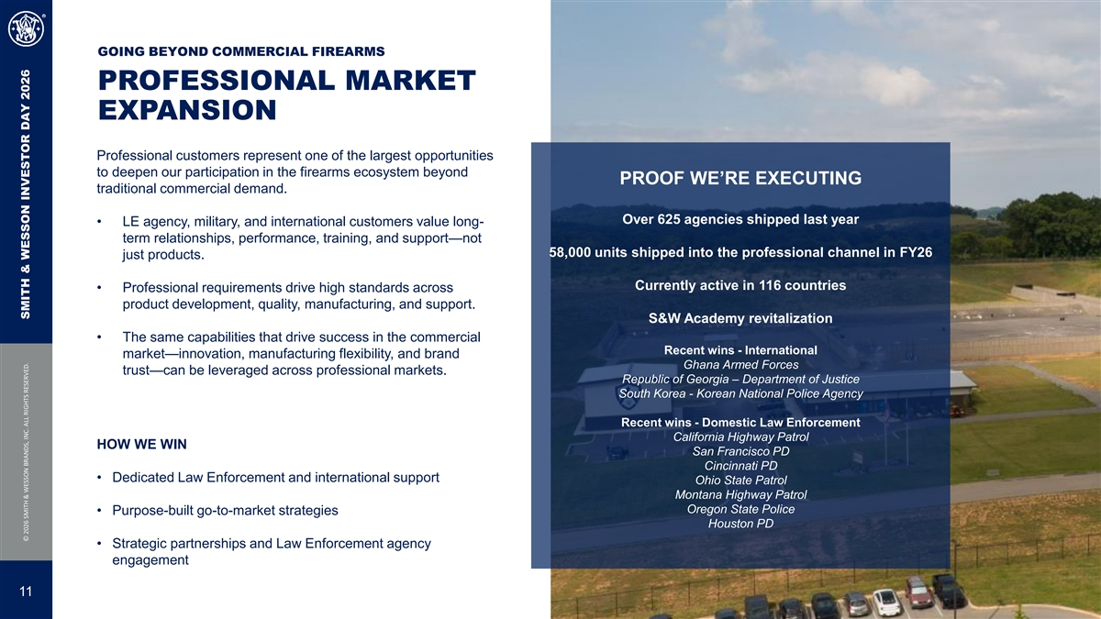
GOING BEYOND COMMERCIAL FIREARMS PROFESSIONAL MARKET EXPANSION Professional customers represent one of the largest opportunities to deepen our participation in the firearms ecosystem beyond PROOF WE’RE EXECUTING traditional commercial demand. Over 625 agencies shipped last year • LE agency, military, and international customers value long- term relationships, performance, training, and support—not 58,000 units shipped into the professional channel in FY26 just products. Currently active in 116 countries • Professional requirements drive high standards across product development, quality, manufacturing, and support. S&W Academy revitalization • The same capabilities that drive success in the commercial Recent wins - International market—innovation, manufacturing flexibility, and brand Ghana Armed Forces trust—can be leveraged across professional markets. Republic of Georgia – Department of Justice South Korea - Korean National Police Agency Recent wins - Domestic Law Enforcement California Highway Patrol HOW WE WIN San Francisco PD Cincinnati PD • Dedicated Law Enforcement and international support Ohio State Patrol Montana Highway Patrol Oregon State Police • Purpose-built go-to-market strategies Houston PD • Strategic partnerships and Law Enforcement agency engagement 11 © 2026 SMITH & WESSON BRANDS, INC. ALL RIGHTS RESERVED. SMITH & WESSON INVESTOR DAY 2026

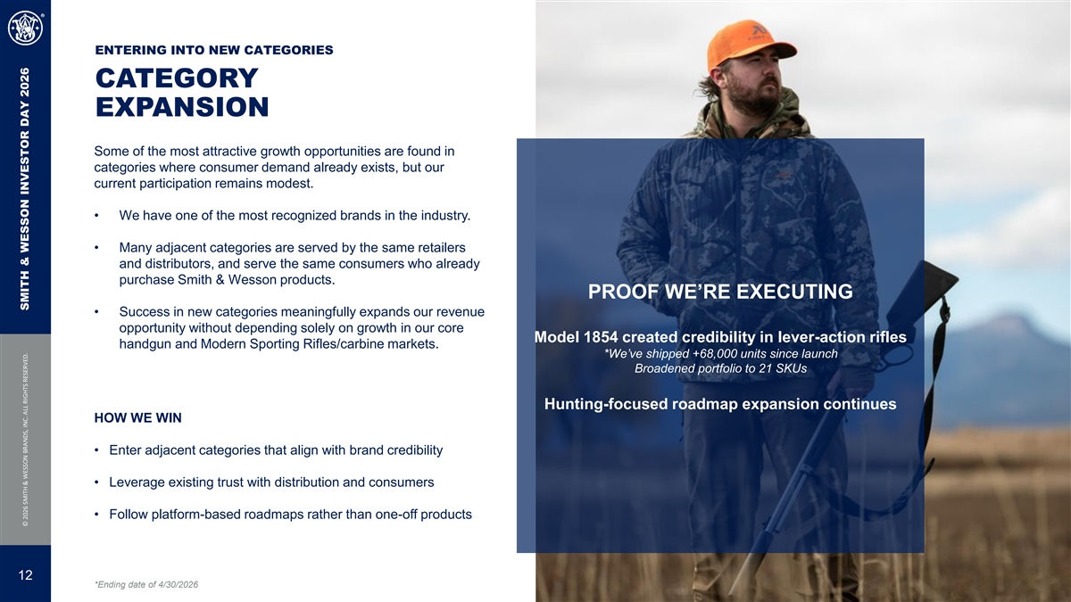
ENTERING INTO NEW CATEGORIES CATEGORY EXPANSION Some of the most attractive growth opportunities are found in categories where consumer demand already exists, but our current participation remains modest. • We have one of the most recognized brands in the industry. • Many adjacent categories are served by the same retailers and distributors, and serve the same consumers who already purchase Smith & Wesson products. PROOF WE’RE EXECUTING • Success in new categories meaningfully expands our revenue opportunity without depending solely on growth in our core Model 1854 created credibility in lever-action rifles handgun and Modern Sporting Rifles/carbine markets. *We’ve shipped +68,000 units since launch Broadened portfolio to 21 SKUs Hunting-focused roadmap expansion continues HOW WE WIN • Enter adjacent categories that align with brand credibility • Leverage existing trust with distribution and consumers • Follow platform-based roadmaps rather than one-off products 12 *Ending date of 4/30/2026 © 2026 SMITH & WESSON BRANDS, INC. ALL RIGHTS RESERVED. SMITH & WESSON INVESTOR DAY 2026

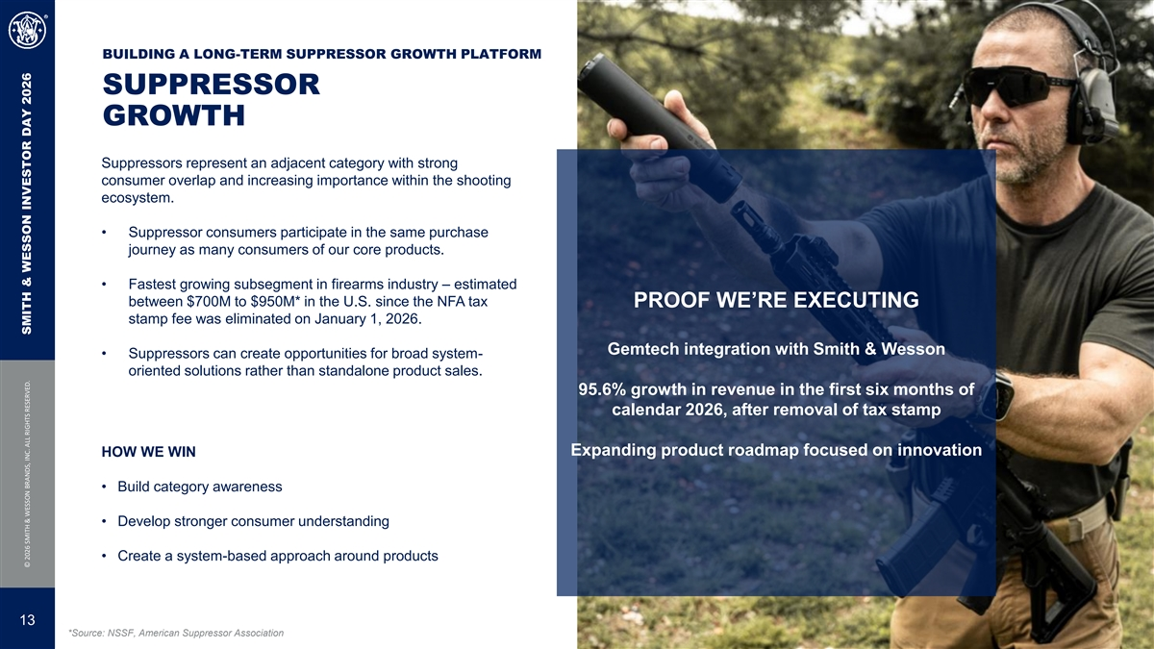
BUILDING A LONG-TERM SUPPRESSOR GROWTH PLATFORM SUPPRESSOR GROWTH Suppressors represent an adjacent category with strong consumer overlap and increasing importance within the shooting ecosystem. • Suppressor consumers participate in the same purchase journey as many consumers of our core products. • Fastest growing subsegment in firearms industry – estimated between $700M to $950M* in the U.S. since the NFA tax PROOF WE’RE EXECUTING stamp fee was eliminated on January 1, 2026. Gemtech integration with Smith & Wesson • Suppressors can create opportunities for broad system- oriented solutions rather than standalone product sales. 95.6% growth in revenue in the first six months of calendar 2026, after removal of tax stamp Expanding product roadmap focused on innovation HOW WE WIN • Build category awareness • Develop stronger consumer understanding • Create a system-based approach around products 13 *Source: NSSF, American Suppressor Association © 2026 SMITH & WESSON BRANDS, INC. ALL RIGHTS RESERVED. SMITH & WESSON INVESTOR DAY 2026

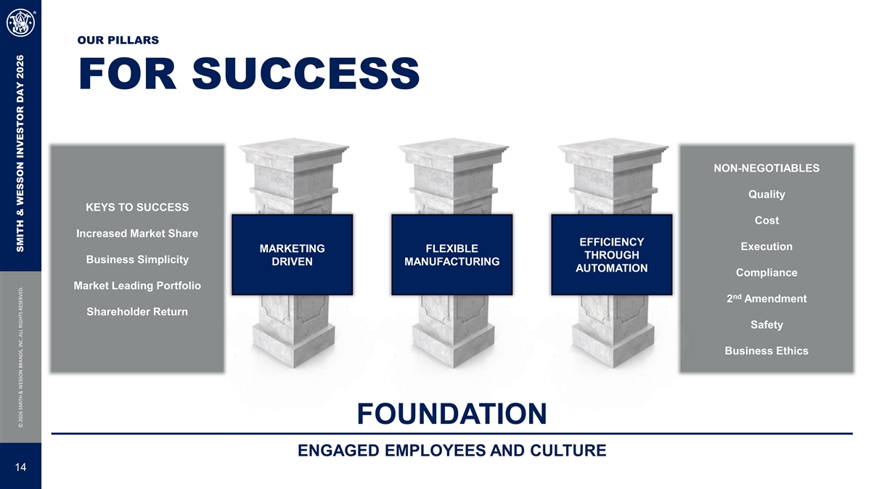
OUR PILLARS FOR SUCCESS NON-NEGOTIABLES Quality KEYS TO SUCCESS Cost Increased Market Share EFFICIENCY Execution MARKETING FLEXIBLE THROUGH Business Simplicity DRIVEN MANUFACTURING AUTOMATION Compliance Market Leading Portfolio nd 2 Amendment Shareholder Return Safety Business Ethics FOUNDATION ENGAGED EMPLOYEES AND CULTURE 14 © 2026 SMITH & WESSON BRANDS, INC. ALL RIGHTS RESERVED. SMITH & WESSON INVESTOR DAY 2026

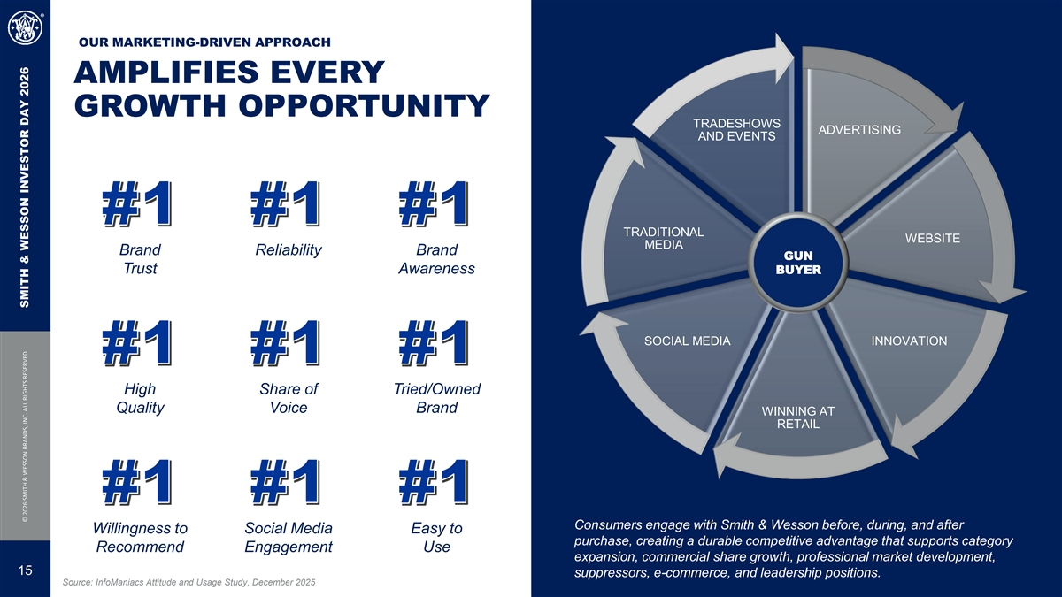
OUR MARKETING-DRIVEN APPROACH AMPLIFIES EVERY GROWTH OPPORTUNITY TRADESHOWS ADVERTISING AND EVENTS #1 #1 #1 TRADITIONAL WEBSITE MEDIA Brand Reliability Brand GUN Trust Awareness BUYER SOCIAL MEDIA INNOVATION #1 #1 #1 High Share of Tried/Owned Quality Voice Brand WINNING AT RETAIL #1 #1 #1 Consumers engage with Smith & Wesson before, during, and after Willingness to Social Media Easy to purchase, creating a durable competitive advantage that supports category Recommend Engagement Use expansion, commercial share growth, professional market development, 15 suppressors, e-commerce, and leadership positions. Source: InfoManiacs Attitude and Usage Study, December 2025 © 2026 SMITH & WESSON BRANDS, INC. ALL RIGHTS RESERVED. SMITH & WESSON INVESTOR DAY 2026

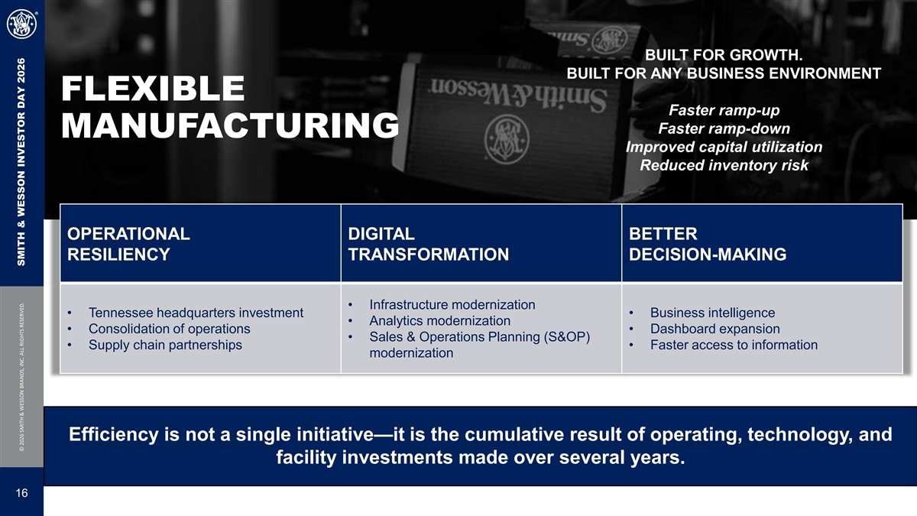
BUILT FOR GROWTH. BUILT FOR ANY BUSINESS ENVIRONMENT FLEXIBLE Faster ramp-up Faster ramp-down MANUFACTURING Improved capital utilization Reduced inventory risk OPERATIONAL DIGITAL BETTER RESILIENCY TRANSFORMATION DECISION-MAKING • Infrastructure modernization • Tennessee headquarters investment• Business intelligence • Analytics modernization • Consolidation of operations• Dashboard expansion • Sales & Operations Planning (S&OP) • Supply chain partnerships• Faster access to information modernization Efficiency is not a single initiative—it is the cumulative result of operating, technology, and facility investments made over several years. 16 © 2026 SMITH & WESSON BRANDS, INC. ALL RIGHTS RESERVED. SMITH & WESSON INVESTOR DAY 2026

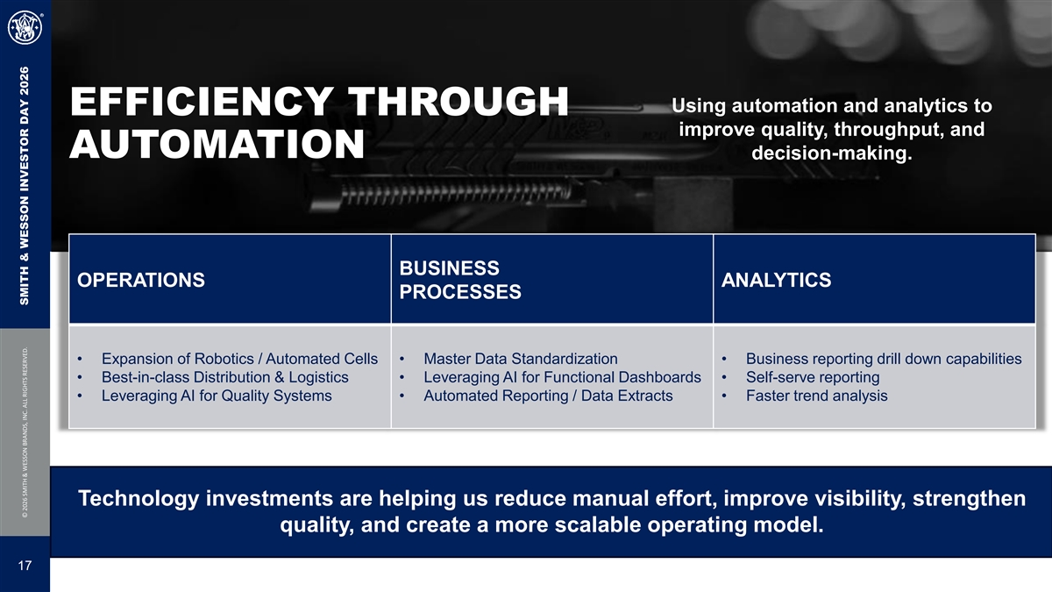
Using automation and analytics to EFFICIENCY THROUGH improve quality, throughput, and AUTOMATION decision-making. BUSINESS OPERATIONS ANALYTICS PROCESSES • Expansion of Robotics / Automated Cells• Master Data Standardization• Business reporting drill down capabilities • Best-in-class Distribution & Logistics• Leveraging AI for Functional Dashboards• Self-serve reporting • Leveraging AI for Quality Systems• Automated Reporting / Data Extracts• Faster trend analysis Technology investments are helping us reduce manual effort, improve visibility, strengthen quality, and create a more scalable operating model. 17 © 2026 SMITH & WESSON BRANDS, INC. ALL RIGHTS RESERVED. SMITH & WESSON INVESTOR DAY 2026

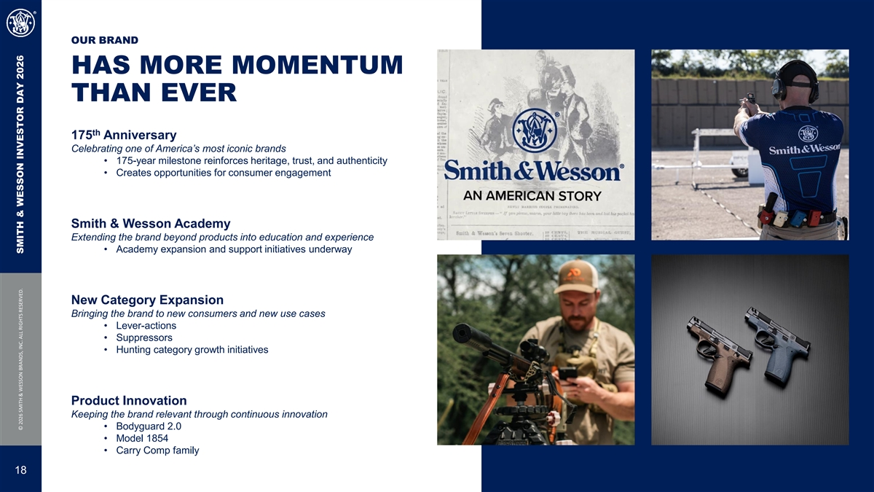
OUR BRAND HAS MORE MOMENTUM THAN EVER th 175 Anniversary Celebrating one of America’s most iconic brands • 175-year milestone reinforces heritage, trust, and authenticity • Creates opportunities for consumer engagement Smith & Wesson Academy Extending the brand beyond products into education and experience • Academy expansion and support initiatives underway New Category Expansion Bringing the brand to new consumers and new use cases • Lever-actions • Suppressors • Hunting category growth initiatives Product Innovation Keeping the brand relevant through continuous innovation • Bodyguard 2.0 • Model 1854 • Carry Comp family 18 © 2026 SMITH & WESSON BRANDS, INC. ALL RIGHTS RESERVED. SMITH & WESSON INVESTOR DAY 2026


QUESTIONS? 19 © 2026 SMITH & WESSON BRANDS, INC. ALL RIGHTS RESERVED.

